IMBALANCE DATA HANDLING :

CLASS IMBALANCE PROBLEM :
It is a familiar problem particularly occurring in classification when we have datasets with an unequal ratio of data points in each class.
If the number of data points in minority class is much less, then it may end up being completely ignored during training.

Techniques to handle Imbalance:

- Class Weights:
Instead of changing data, change how much mistakes cost.
- Minority class → higher penalty
- Majority class → lower penalty
Example:
model = LogisticRegression(class_weight='balanced')
Here the Model is forced to care more about minority class
Advantage:
- No data duplication
- Works well in many cases
Disadvantage:
- Not enough for extreme imbalance

Synthetic Minority Oversampling Technique (SMOTE)

It ​​is used to generate artificial/synthetic samples for the minority class. This technique works by randomly choosing a sample from a minority class and determining K-Nearest Neighbors for this sample, then the artificial sample is added between the picked sample and its neighbors. This function is present in imblearn module.

Working of SMOTE Algorithm ;

An algorithm called SMOTE (Synthetic Minority Over-sampling Technique) is used to rectify dataset class imbalances. To put it briefly, SMOTE generates synthetic samples for the minority class. Here is a quick rundown of how it functions:
- Identify minority class instances: Determine which dataset instances belong to the minority class.
- Select a Minority Instance: Select a minority instance at random from the dataset.
- Find Nearest Neighbors: Determine which members of the minority class are the selected instance's k-nearest neighbors.
- Generate Synthetic Samples: By dividing the selected instance by the distance between it and its closest neighbors, create synthetic instances. Usually, to accomplish this, a synthetic instance is made along the line that connects the selected instance and the neighbor, and a random neighbor is chosen.
Syntax: SMOTE(sampling_strategy='auto', random_state=None, k_neighbors=5, n_jobs=None)
Parameters:
- sampling_strategy: Sampling Information for dataset
- random_state: Used for shuffling the data. If positive non zero number is given then it shuffles otherwise not. Default value is None.
- k_neighbors: Number count of nearest neighbours used to generate artificial/synthetic samples. Default value is 5
- n_jobs: Number of CPU cores to be used. Default value is None. None here means 1 not 0.
Advantage:
- Better than simple duplication
- Reduces overfitting
Disadvantage:
- Can create fake/noisy data
- Bad for high-dimensional sparse data (like text)

Metric Selection:
Confusion matrix is a simple table used to measure how well a classification model is performing. It compares the predictions made by the model with the actual results and shows where the model was right or wrong. This helps you understand where the model is making mistakes so you can improve it.
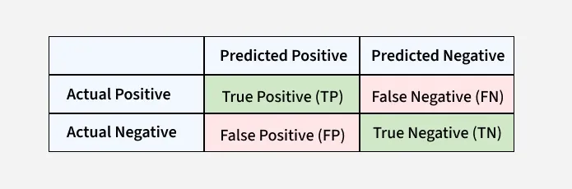
Precision:
Precision is the ratio between the True Positives and all the Positives. It shows how many of the “yes” predictions made by the model were actually correct. It helps us reduce wrong “yes” guesses which are called false positives (FP).
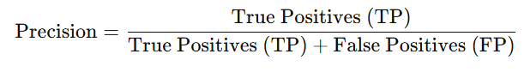

Advantages:
- Controls false positives
- Useful when wrong positive predictions are costly
  - Spam filter (don’t mark legit emails as spam)
  - Loan approval (don’t approve risky users)

Disadvantages
- Ignores false negatives completely
- You can cheat:
  - Predict very few positives → precision looks high
RECALL:
Recall tells us how well a model finds all the correct “yes” cases in the data. It checks how many real positive cases the model was able to correctly identify.
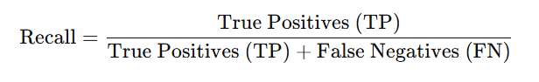Advantages
- Captures how many actual positives you find
- Missing a real case is dangerous or costly. For example in cybersecurity missing an attack is worse than accidentally flagging something safe.

Disadvantages
- Can lead to too many false positives
F1 Score:
F1 Score is a metric used to evaluate the performance of a classification model. It combines precision and recall into a single value and is especially useful when the dataset has imbalanced classes.
- Combines precision and recall into one metric.
- Useful for imbalanced datasets.
- Higher F1 Score means better performance.
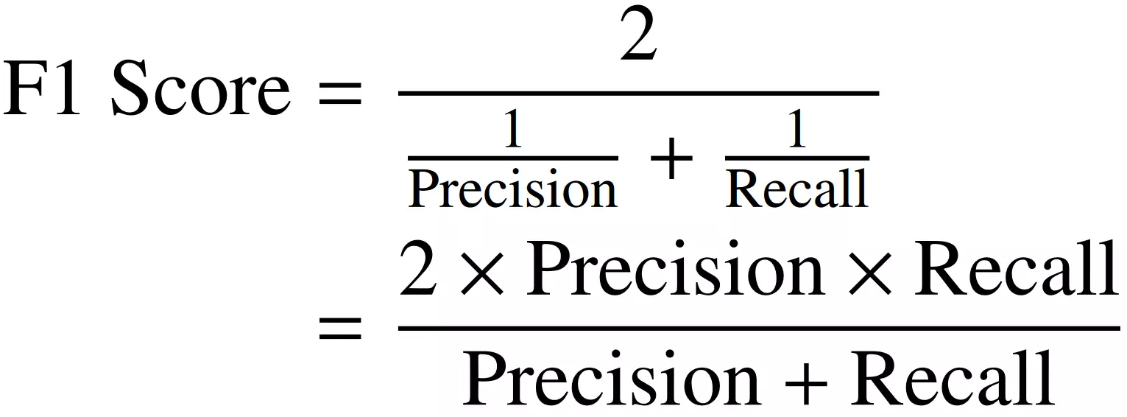

Advantages
- Combines precision + recall
- Good for imbalanced datasets
- Penalizes extreme imbalance between them

Disadvantages
- Ignores true negatives (TN)
- Doesn’t tell you what kind of mistake you're making
- Harder to interpret for business people
AUC ROC CURVE:
AUC (Area Under the Curve)
ROC (Receiver Operating Characteristic) Curve
AUC-ROC curve is a graph used to check how well a binary classification model works. It shows how good the model is at telling the difference between the two classes by plotting.
Specificity: measures the proportion of actual negatives that the model correctly identifies. It is calculated as 1 - FPR.
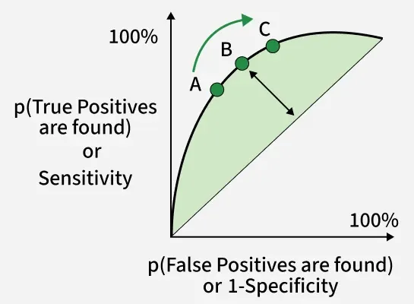

AUC-ROC is effective when:
- The dataset is balanced and the model needs to be evaluated across all thresholds.
- False positives and false negatives are of similar importance.

Advantages
- Threshold-independent
- Works well for model comparison
- Gives overall performance view

Disadvantages
- Can be misleading in highly imbalanced data
- Doesn’t reflect real-world threshold decisions
- Hard to explain to stakeholders

